Ten things to know about Canada’s guaranteed annual

income debate

calgaryhomeless.com/blog/ten-things-to-know-about-canadas-guaranteed-annual-income-debate

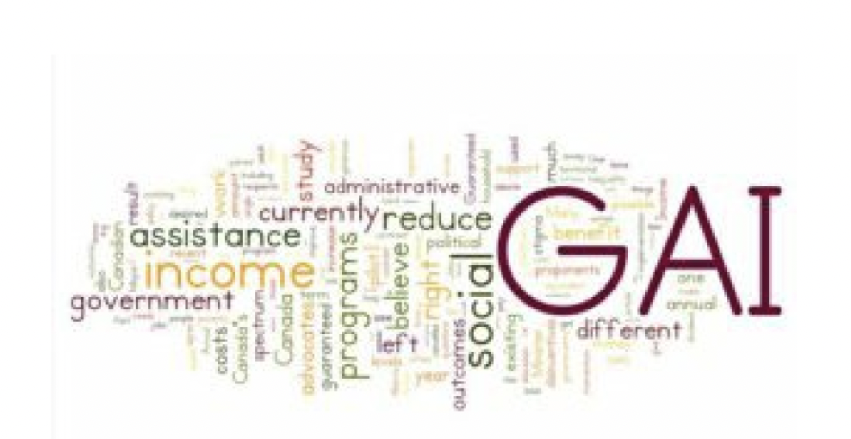

By: Nick Falvo, Ph.D., Director, Research and Data, CHF

The possibility of implementing a Guaranteed Annual Income (GAI) is currently one of the

hottest topics in Canadian social policy. It gained momentum earlier this year when the

Ontario government announced it would undertake a pilot study of the GAI. And in June, the

Ontario government announced that former Canadian Senator Hugh Segal will advise them on

the “design and implementation” of the pilot. A discussion paper he has authored is expected

to be made public this fall, and three months of consultations will start soon in Ontario.

The main idea behind a GAI is to give every adult in Canada a fixed amount of money with few

if any conditions and to do away with several other types of income assistance programs

(especially social assistance).[1]

Here are 10 things to know about Canada’s GAI debate:

1. The various proposed GAI schemes have multiple names. The following terms are

often used interchangeably: basic income, guaranteed annual income, negative income

tax, guaranteed livable income, guaranteed adequate income, social dividend, territorial

dividend, state bonus, demogrant, assured annual income and citizen’s wage. Each

comes with slightly different connotations and different ‘camps’ of advocates have their

own reasons for favouring one term over the other. As of 2009, the most used term in

English Canada was the Guaranteed Annual Income; though more recently ‘basic

1/4

income’ has gained momentum and is the term currently used by the Ontario

Government.

2. There’s already been a Canadian pilot study done on the GAI.From 1974 until 1979,

a big GAI study was done in Manitoba known as the MINCOME experiment. Successful

outcomes from this study (including evidence that the GAI demonstrated notable health

improvement among recipients, without reducing labour supply very much) are often

cited in support of a broader adoption of a GAI across Canada.

3. It’s not clear who would get the GAI or how much of it they’d get to keep.Some

GAI advocates say a well-designed GAI would be ‘phased out’ as an individual’s income

rises—i.e. funds paid to individuals who already make more than the GAI would be taxed

back. What’s more, some GAI proposals in the past have excluded young single people.

Some advocates also believe that different age groups should receive different benefit

amounts. Some believe that immigrants should be excluded from such a scheme until

such time that they become full-fledged citizens. But other advocates think the GAI

should go to everybody and that everybody should be able to keep the full amount.

4. Many proponents of the GAI believe it would result in lower administrative costs.

One argument in favour of the GAI is that it would result in reduced need for

administrative staff. For example, in some Ontario jurisdictions, more than 30% of the

total costs of social assistance are attributable to administrative costs. By contrast, my

colleague John Stapleton estimates that administrative costs for a benefit where

eligibility is determined via the tax system account for just 2-3% of the benefit. But

remember: “lower administrative costs” would likely translate into job losses—

specifically, the loss of relatively well-paying jobs currently held overwhelmingly by

women. Across Canada, more than three-quarters of community and social service

workers are women.

5. The idea of a GAI has support on both the left and right of the political spectrum.

Those on the left tend to believe that doing away with other programs will reduce stigma

(e.g. the sometimes humiliating experience of having to answer intrusive questions by a

welfare worker) and achieve adequacy. Those on the right of the political spectrum like

the fact that the GAI might reduce work disincentives currently in place with means-

tested programs (e.g. earned income being ‘clawed back’ for social assistance

recipients). Those on the right also like the fact a GAI could result in ‘smaller

government’—i.e. less regulation pertaining to existing programs. (For more on the

GAI’s broad political appeal, see this 1989 article, as well as this more recent piece by

John Clarke.)

6. One reason the GAI has support on both the left and right is that advocates on

each side of the spectrum appear to have different ideas as to how generous the

GAI would be. Many on the left envisage it as being equivalent to Statistics Canada’s

low income measure. As you can see from this table, that would be about $20,000 for a

one-income household, $30,00 for a two-person household and $40,000 for a four-

person household. Many on the right, by contrast, believe the GAI should be equivalent

to current social assistance benefit levels. In Alberta, a ‘single employable’ adult on

social assistance receives about $8,000 a year. (For more on social assistance benefit

2/4 levels across Canada, see this report.)

7. Not all proponents of a GAI agree on its desired outcomes.Depending on who you

ask, the GAI appears to have at least a dozen possible desired outcomes: Is the desired

outcome to reduce work disincentives?[2] Is it to reduce stigma? Is it to reduce

poverty? Is it to reduce income inequality? Is it to reduce wealth inequality? Is it to

increase the generosity of benefits for those currently receiving social assistance? Is it

to reduce food insecurity? Is it to improve health outcomes? Is it to improve educational

outcomes? Is it to increase gender equality? Is it to increase literacy levels? Is it to

decrease criminal activity? Is it all of the above?

8. Like any social policy initiative, a GAI could have unintended consequences.

Specifically, a GAI—particularly one that’s more generous—could potentially create work

disincentives of its own. To put it crudely, if the GAI were to make life ‘more comfortable’

for persons not working (and if it were to reduce the stigma currently associated with

social assistance) it’s possible that some people currently working at low-wage,

precarious jobs would decide to work less. That’s precisely what this 2013 study

found—a study co-authored by Jean-Yves Duclos, who is now Canada’s Minister of

Families, Children and Social Development. He is also the Minister mandated by Prime

Minister Trudeau to “[l]ead the development of a Canadian Poverty Reduction

Strategy...”[3] Whether this potential outcome is deemed a good thing or bad thing

depends in part on whether one is on the right or left of the political spectrum.

9. It’s hard to estimate the GAI’s cost. When it comes to how much money the GAI

should provide to households, there are important differences of opinion between those

on the left and those on the right. With so many different possible approaches, it’s hard

to ‘cost out’ a GAI. Some proponents believe the GAI would pay for itself and maybe

even save money; others believe it would result in more than $100 billion in additional

annual program spending each year (net of savings). During any discussion about the

GAI, important questions to ask include: Which existing programs would be cancelled?

Would Old Age Security and the Guaranteed Income Supplement be cancelled? Would

Employment Insurance be eliminated? (According to a recent CBC News article, the

Ontario government has indicated that its upcoming pilot won’t “eliminate or consolidate

existing poverty-reduction programs, but rather be designed as a top-up to such

programs to lift its voluntary participants above the poverty line.”)

10. The implementation of a GAI would require a considerable amount of

intergovernmental cooperation. How realistic is it to expect all 10 provincial

governments, all three territorial governments and the federal government to agree on

how much a person needs to live on each year? Which order of government would set

the rules? Which would pay for it? Which would administer it? Would there be a

separate program in Quebec? How would this work on reserves? How will Indigenous

leaders be consulted and where will the funding come from?

In Sum. In recent times, Calgary Mayor Nenshi and Edmonton Mayor Iveson have suggested

it is time for Alberta to consider a GAI alternative in the province. Any forward movement on a

GAI should give serious consideration to all factors and implications of a GAI, including the

intricacies of either phasing out or maintaining existing programs, the needs of specialized

¾ populations and cost-sharing.

The author wishes to thank the following individuals for invaluable assistance in preparing this

blog post: Robbie Brydon, Hilary Chapple, Herb Emery, Evelyn Forget, Louise Gallagher, Rob

Gillezeau, Darcy Halber, Alex Himelfarb, Seth Klein, Ron Kneebone, Diana Krecsy, Aaron Li,

David Macdonald, Joe Manion, Lynn McIntyre, Kevin Milligan, Allan Moscovitch, Gautam

Mukherjee, Jim Mulvale, Sheila Regehr, Gayle Rees, Mario Seccareccia, Munir Sheikh,

Richard Shillington, Wayne Simpson, Madison Smith, John Stapleton and Margot Young.

The views expressed in this blog post are those of the author, and not necessarily those of the

Calgary Homeless Foundation. Any errors are his.

[1] For a history of the GAI, see this link.

[2] It’s not entirely clear to me that Canada has a ‘work disincentive’ problem to begin with.

According to the most recent Labour Force Survey, there are more than 1.3 million Canadians

actively searching for work. Why do we need more?

[3] Curiously though, he’s also recentlyexpressed public support for a GAI for Canada.